Nama : Cheryl Almeira

NIM : 2440054001

GLSC III

**Hasil**

* Tampilan Awal

* Tampilan Form

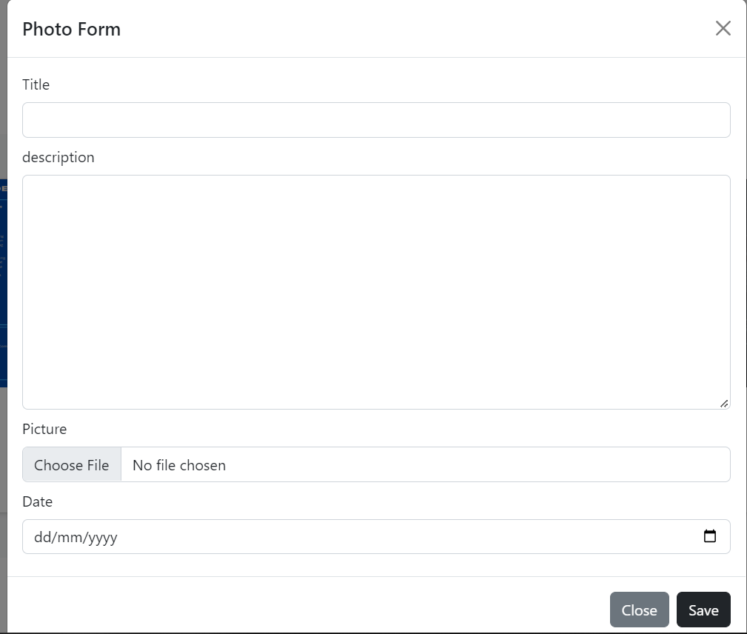

* Tampilan Database

**Code**

* Controller

* Model

* Migrations

* Seeder

* Routes

* Home

* Storage

